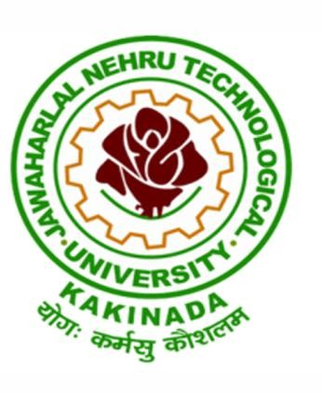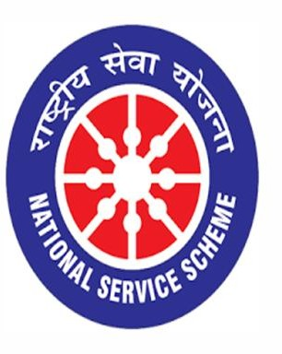

NSS SPECIAL CAMP
15/03/2020 to 19/03/2020

VIGNAN INSTITUTE OF PHARMACEUTICAL TECHNOLOGY
www.vignanpharma.com (Approved by AICTE, PCI New Delhi & Affiliated to JNTUK). Estd.2006.
An ISO 9001:2015, ISO 14001:2015, OHSAS 18001:2007 Certified Institution
Beside VSEZ ,Kapujaggaraju peta Duvvada, Visakhapatnam-530049. A.P
Phone 0891-2511222/2589777, Fax: 0891-2752333:: email : viptvizag@gmail.com

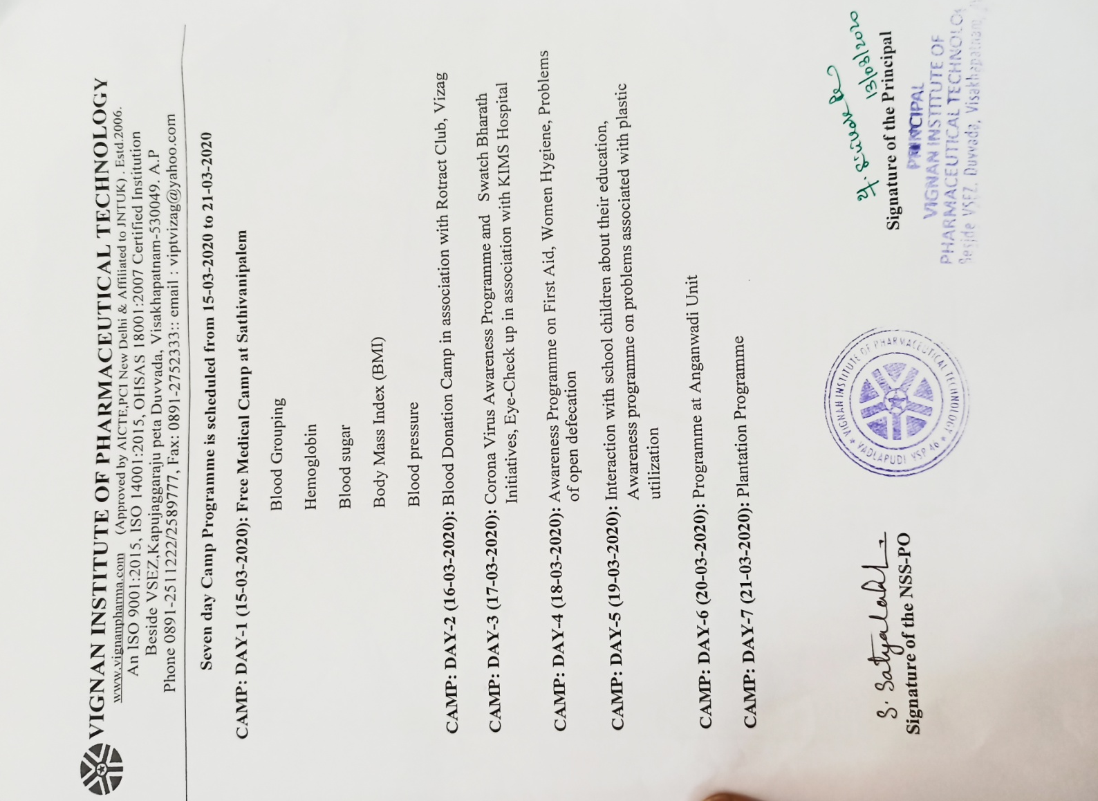

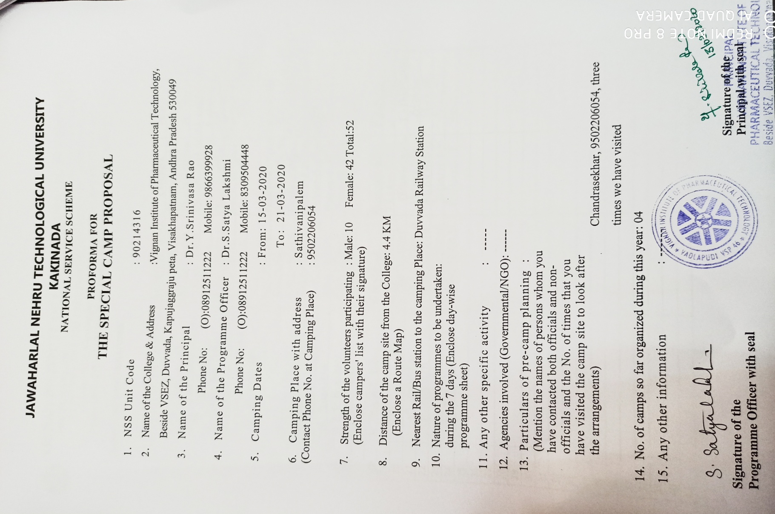

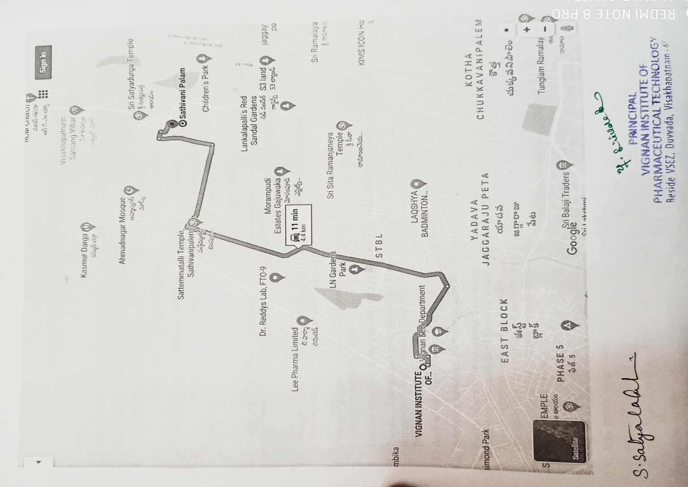

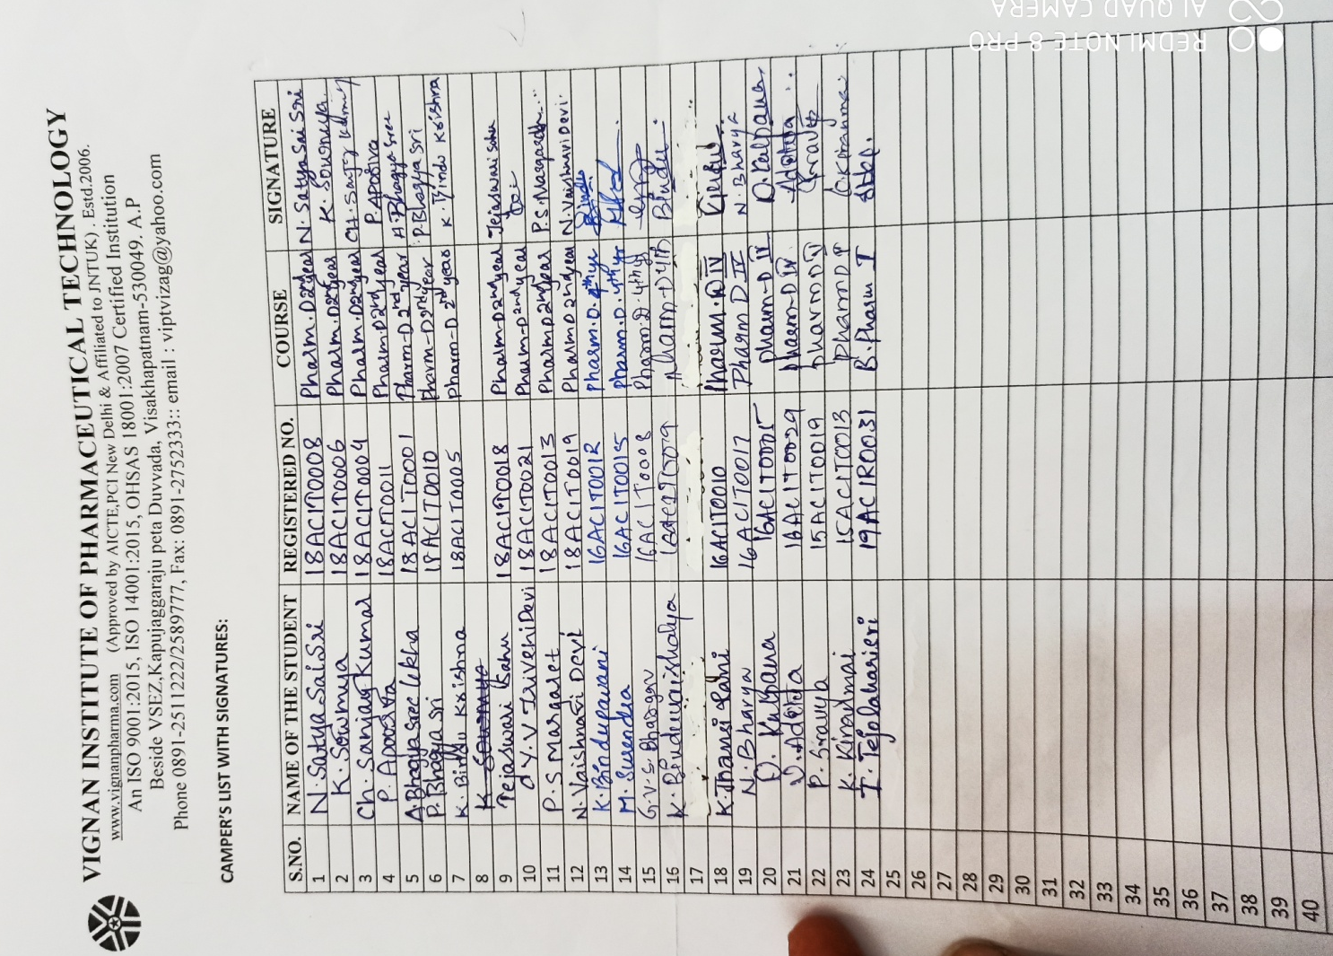

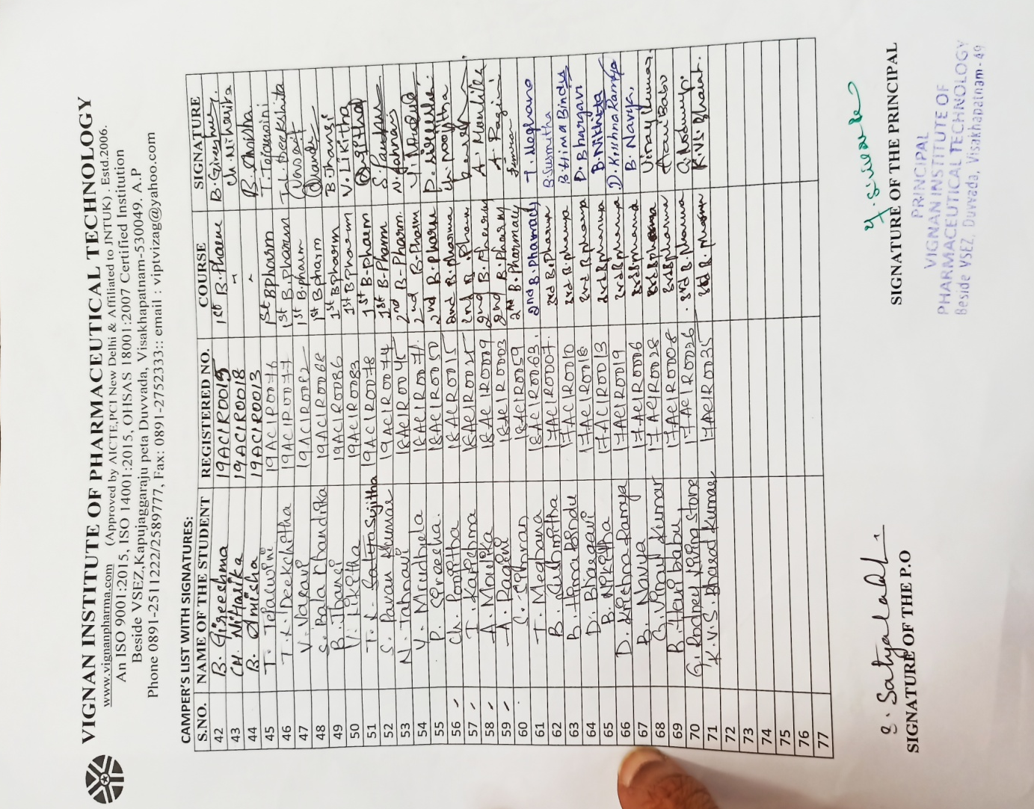

VIGNAN INSTITUTE OF PHARMACEUTICAL TECHNOLOGY
www.vignanpharma.com (Approved by AICTE, PCI New Delhi & Affiliated to JNTUK). Estd.2006.
An ISO 9001:2015, ISO 14001:2015, OHSAS 18001:2007 Certified Institution
Beside VSEZ,Kapujaggaraju peta Duvvada, Visakhapatnam-530049. A.P
Phone 0891-2511222/2589777, Fax: 0891-2752333:: email : viptvizag@gmail.com

REPORT

Date: 19/03/2020

NSS UNIT of VIPT has proposed to conduct a seven days camp in the adapted village Sattivanipalem from 15/03/2020 to 21/03/2020. Because of Covid 19 pandemic we conducted the camp for 5 days. The below are the details of activities conducted.

1. Medical camp
2. Plantation in school and village premises
3. Swachh Bharat Initiatives, importance of sanitization and hygiene
4. Eye checkup in association with KIMS Hospital
5. Awareness on Covid 19 to school children and to villagers
6. Conducted activities to school and Anganwadi children

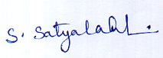
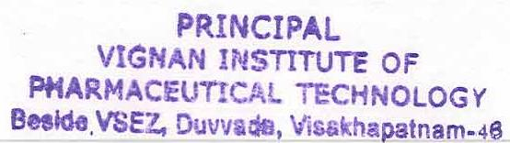
NSS Coordinator Principal

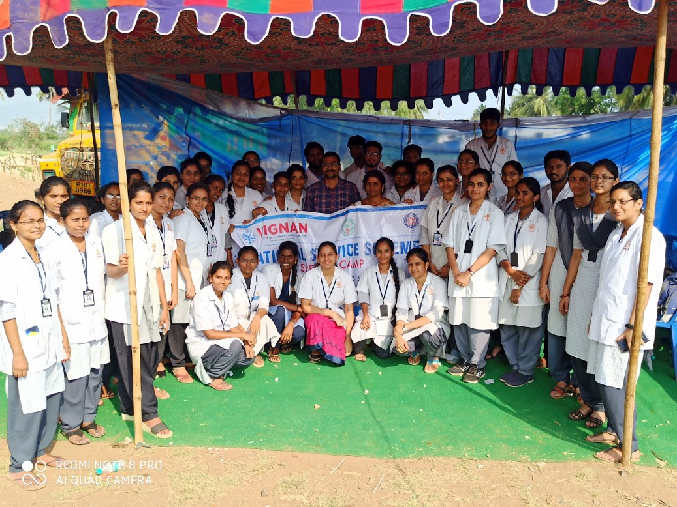
Medical Camp at Sattivanipalem

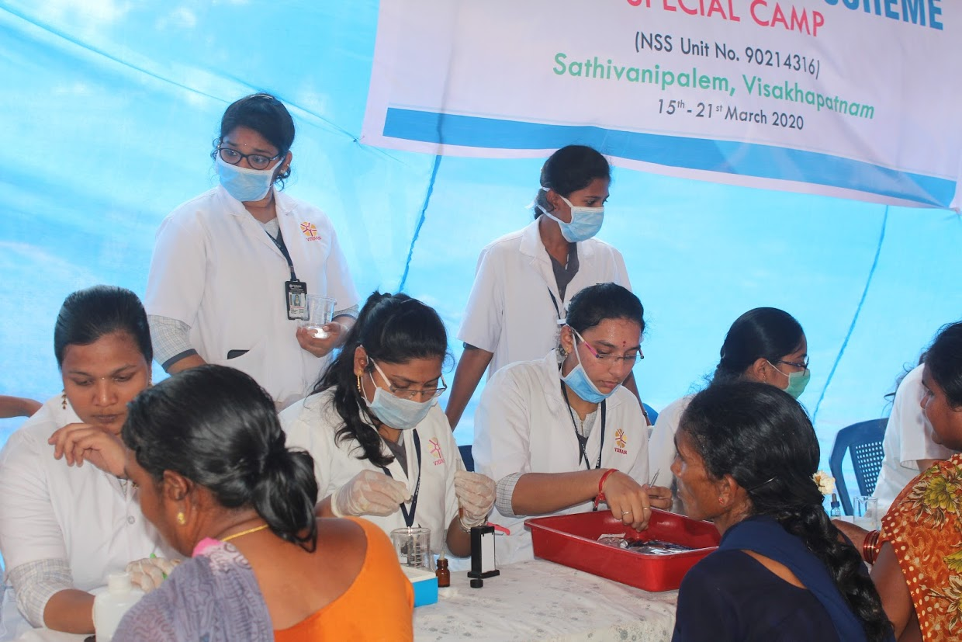

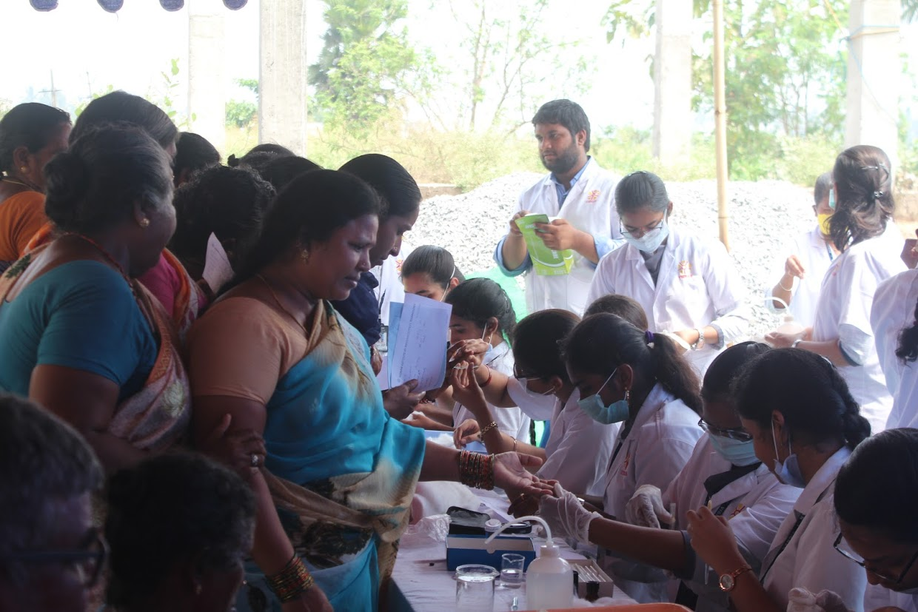

Medical Camp at Sattivanipalem
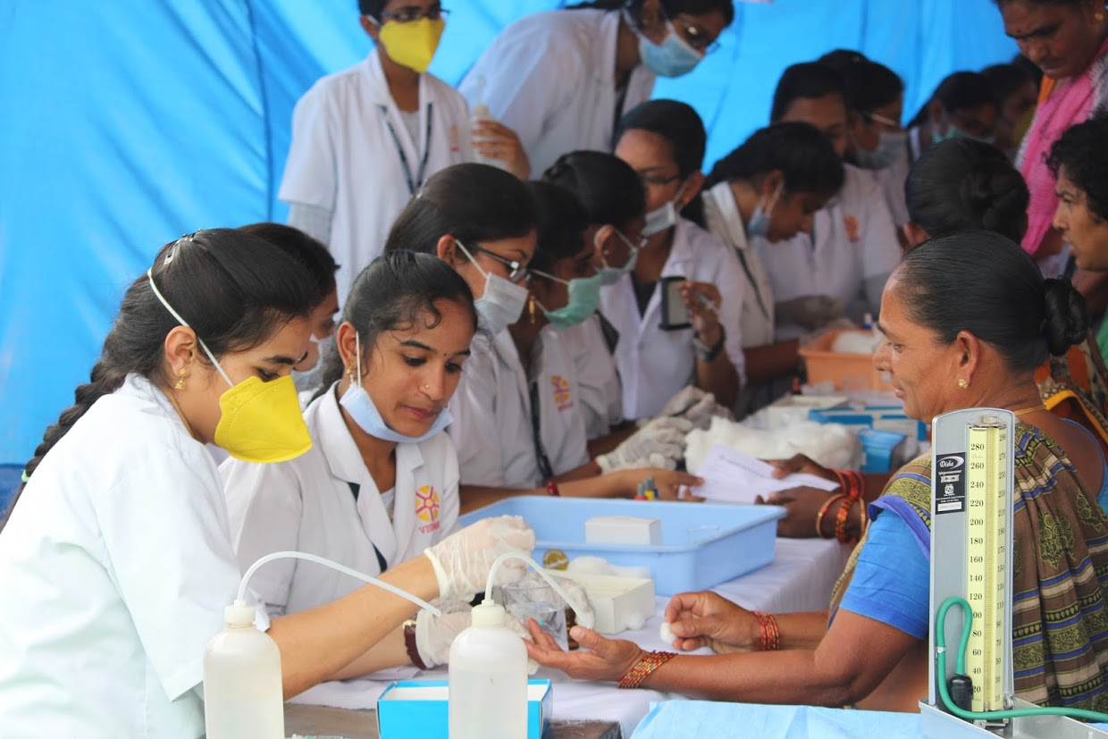

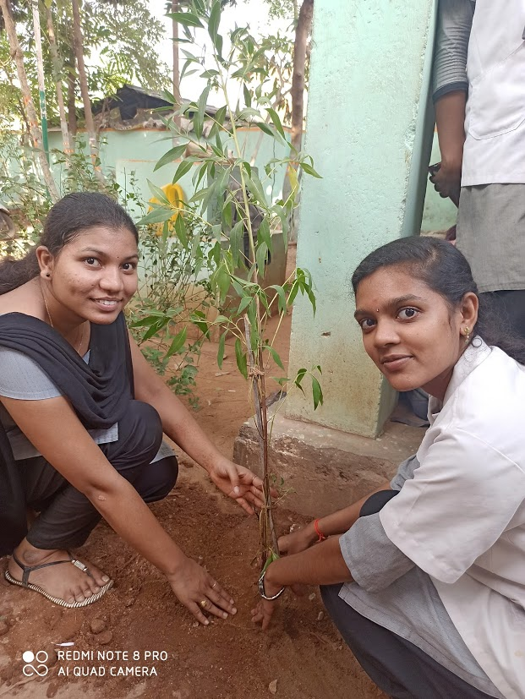

Plantation in School Premises

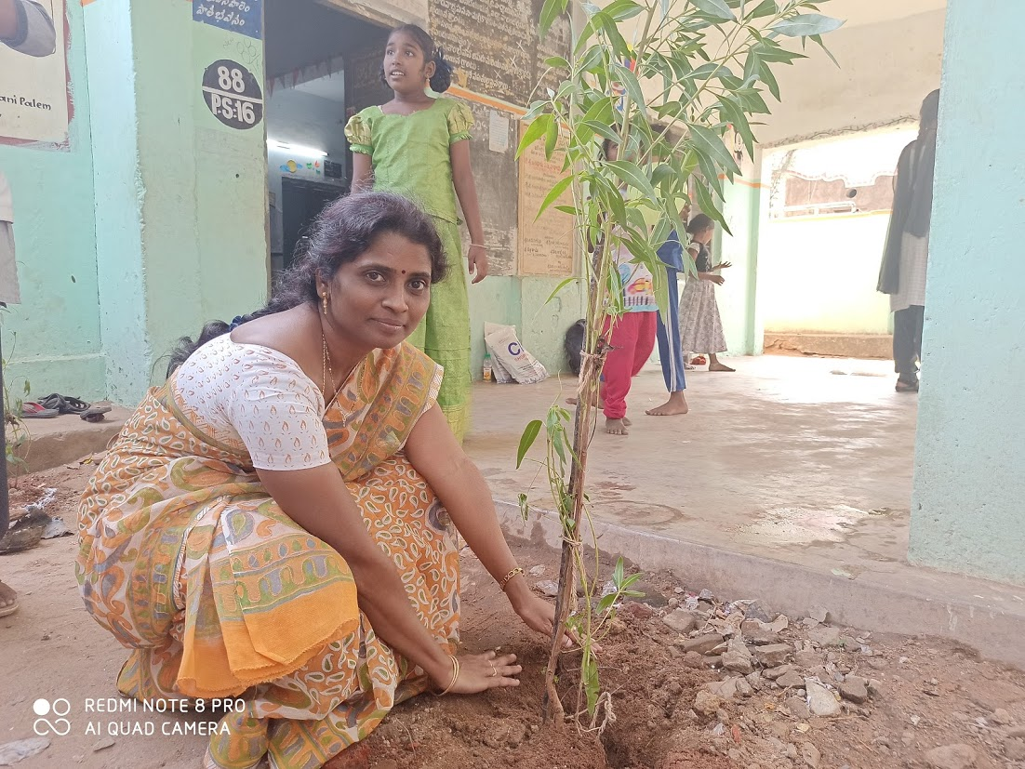
Plantation in School Premises
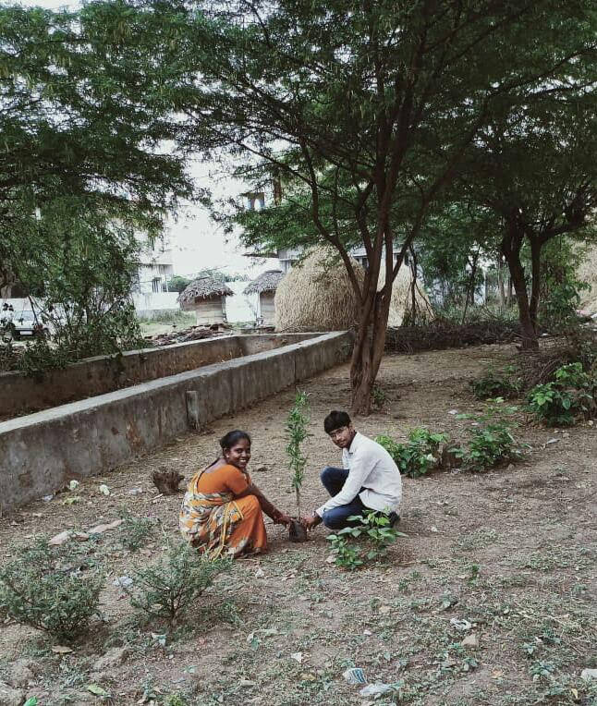
Plantation in Adapted Village

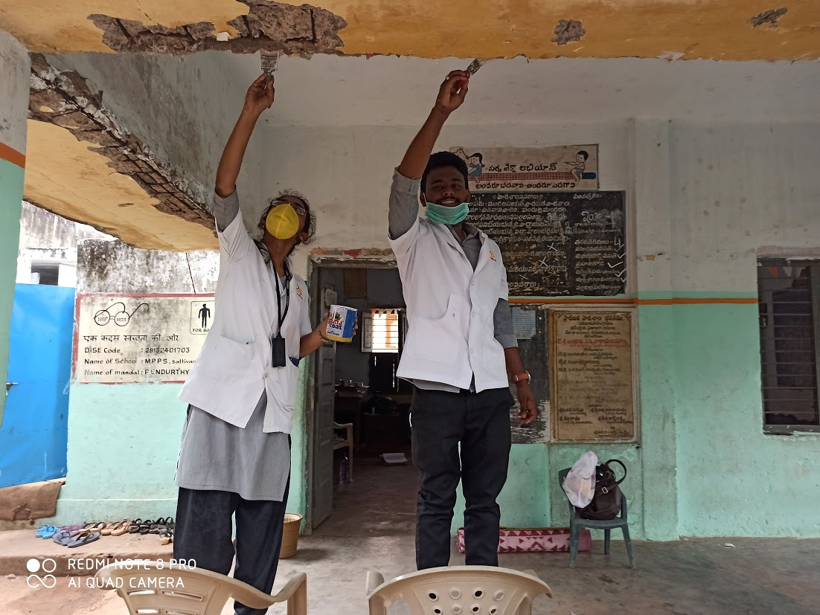

Cleaning and decoration of School in Sattivanipalem
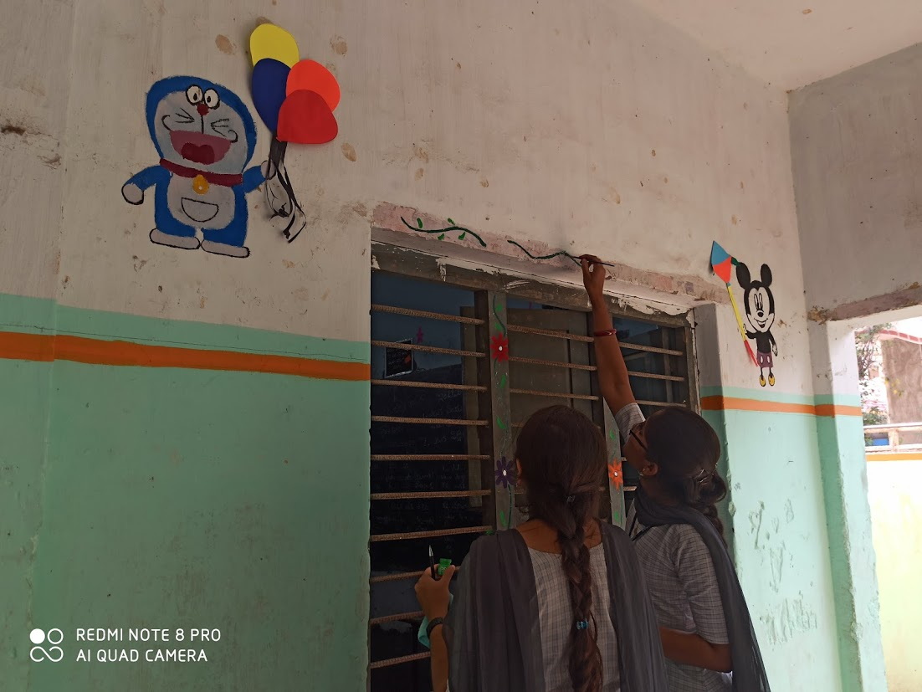

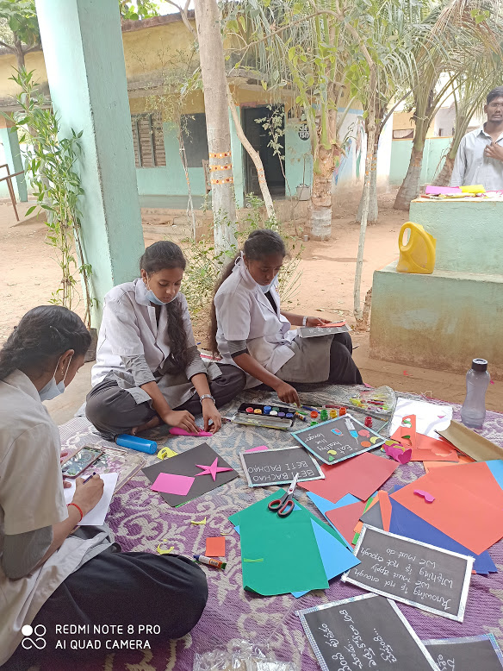

School Decoration

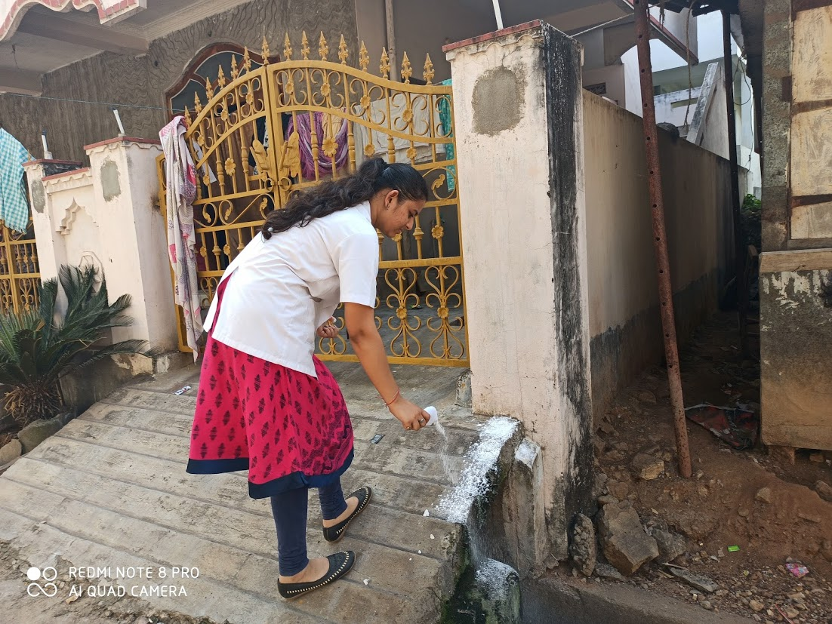
Sanitization of school and village premises

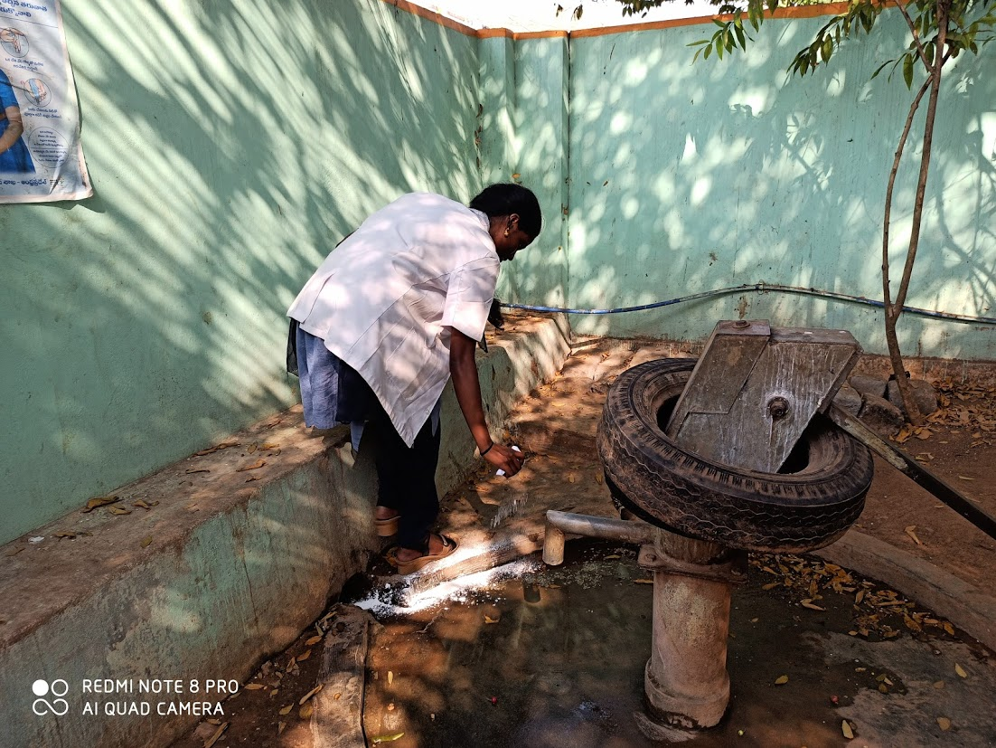

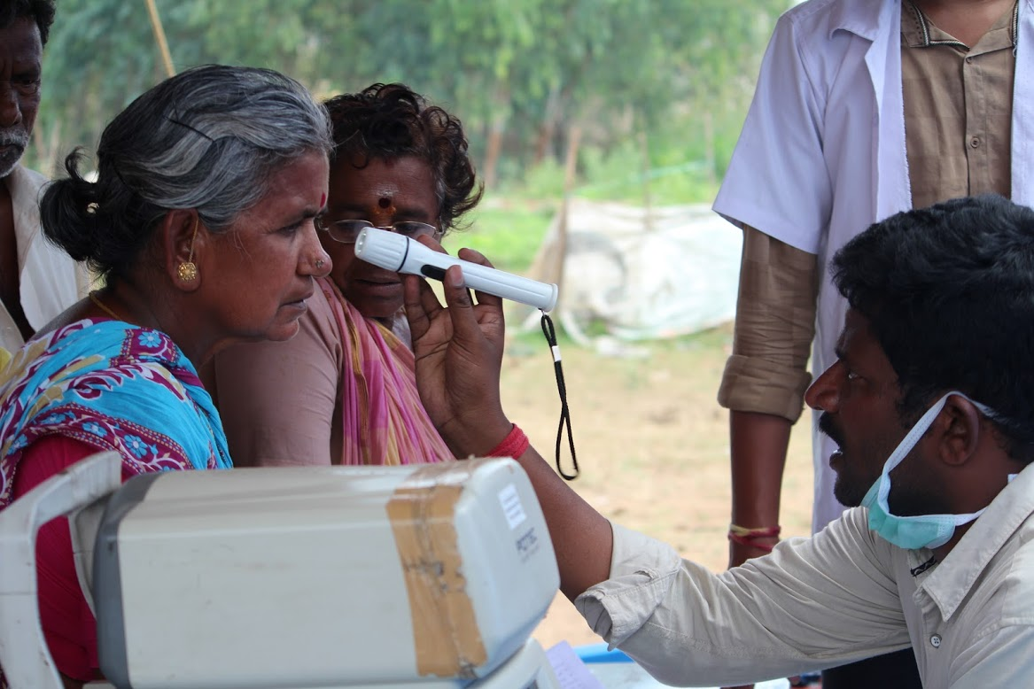

Eye checkup to villagers

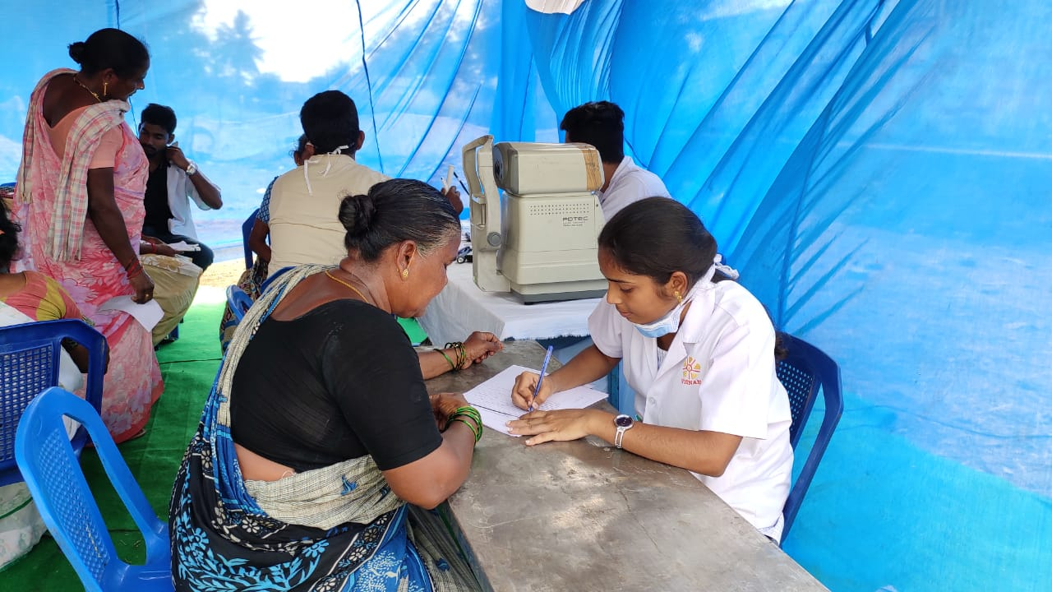

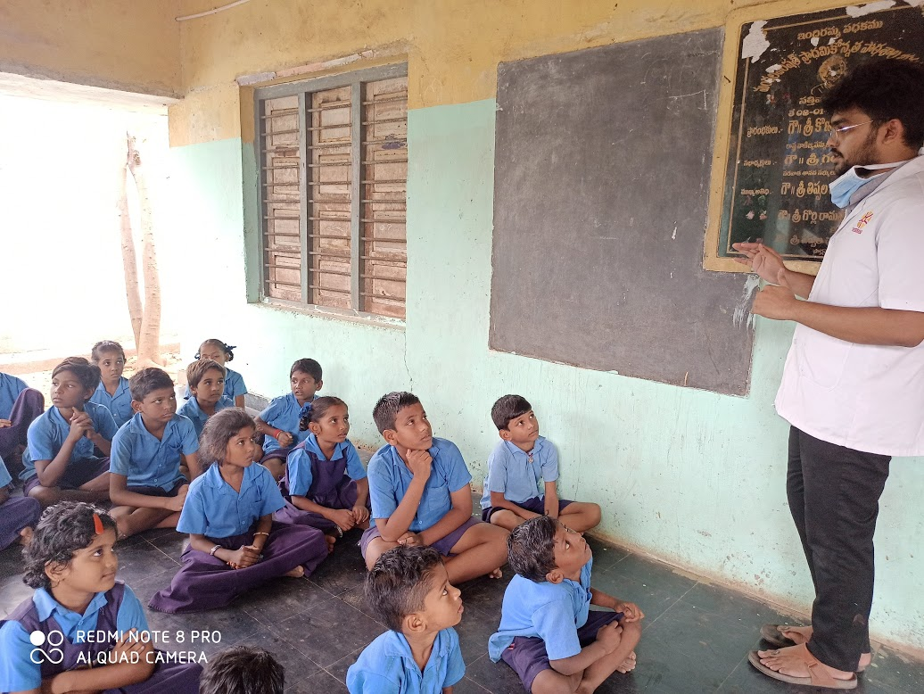
Awareness on Covid 19 to school Children and to Villagers
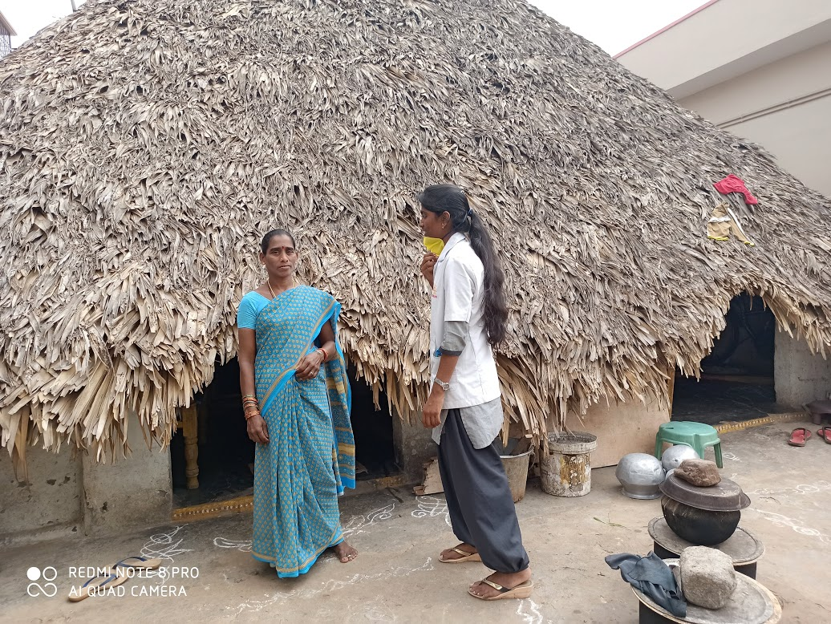

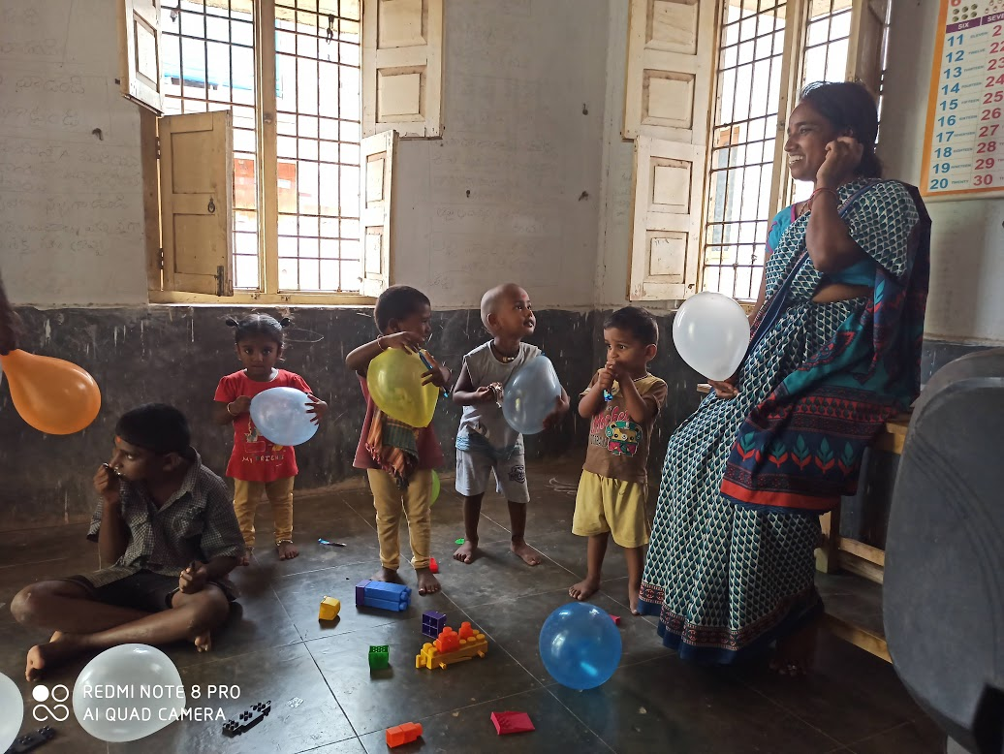
Activities were conducted to Anganwadi and School Children
