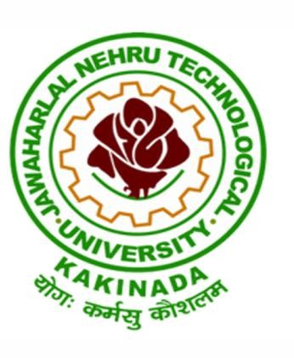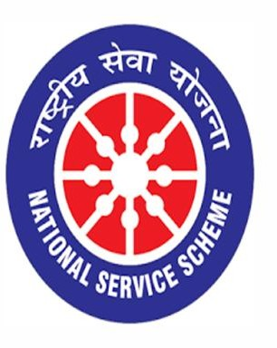

FREE MEDICINE DISTRIBUTION

12/04/2021

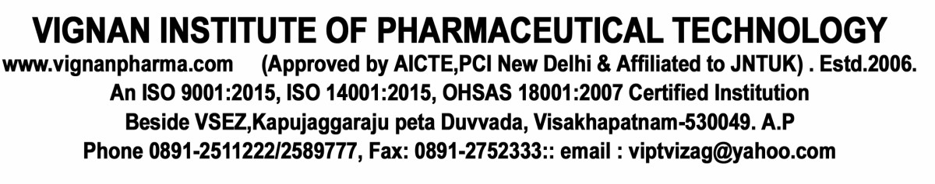

VIGNAN INSTITUTE OF PHARMACEUTICAL TECHNOLOGY
www.vignanpharma.com (Approved by AICTE, PCI New Delhi & Affiliated to JNTUK). Estd.2006.
An ISO 9001:2015, ISO 14001:2015, OHSAS 18001:2007 Certified Institution
Beside VSEZ,Kapujaggaraju peta Duvvada, Visakhapatnam-530049. A.P
Phone 0891-2511222/2589777, Fax: 0891-2752333; email: viptvizag@gmail.com

REPORT Date: 12/04/2021

- NSS UNIT of VIPT has distributed medicines freely to workers and daily labour.
- Nearly 100 people received these free medicines.
- Calcium with vitamin D₃ has distributed to prevent respiratory tract infections in workers.
- Multivitamin tablets also distributed to workers in the campus to boost immune system to fight against Covid-19.

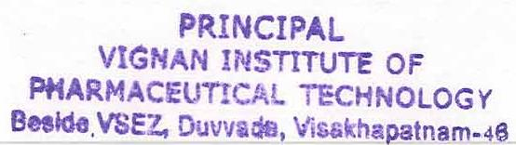
NSS Coordinator Principal

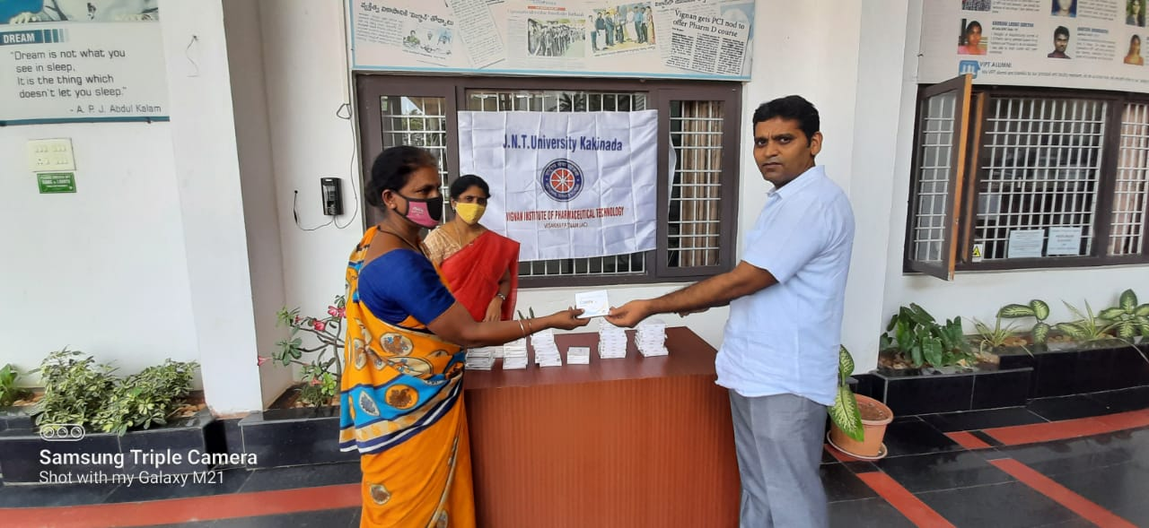

Free medicine distribution to daily workers

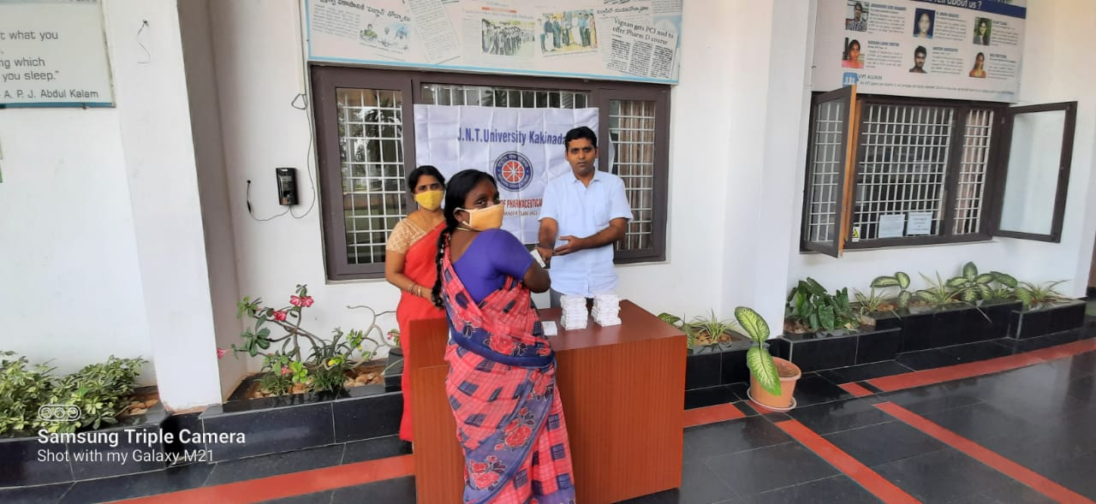

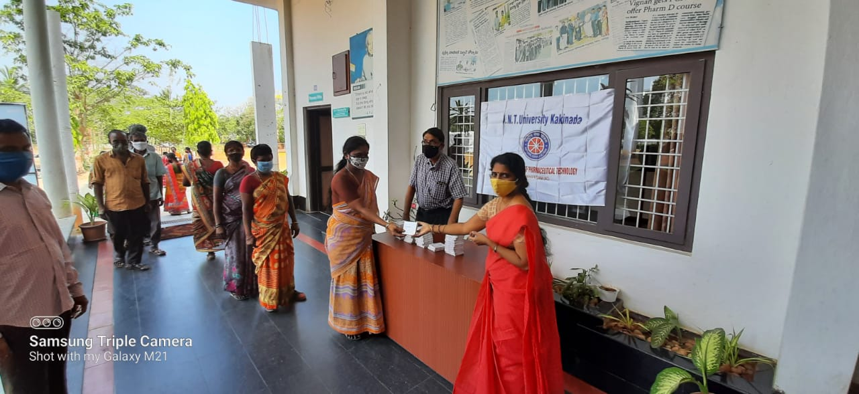

Free medicine distribution to daily workers

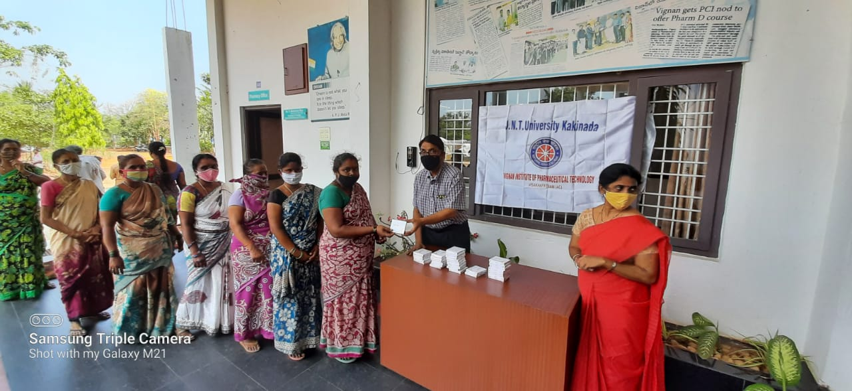

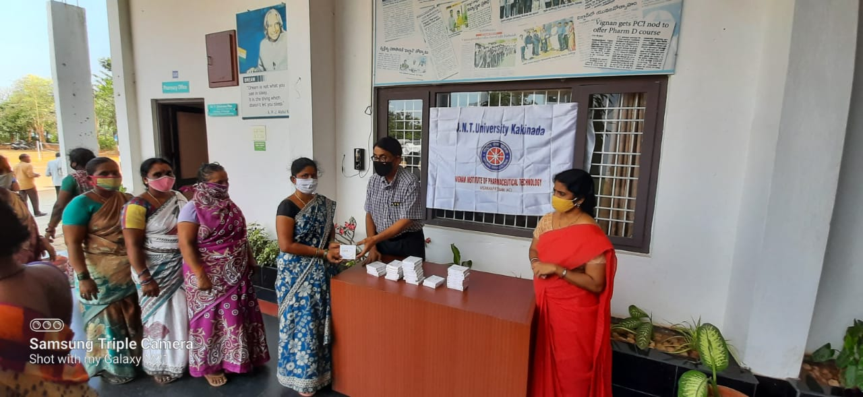

Free medicine distribution to daily workers

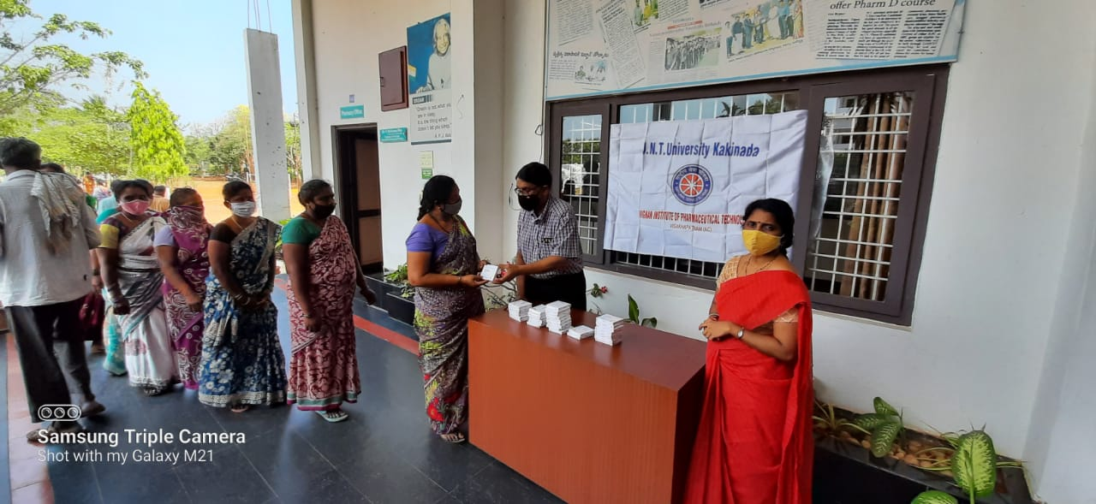

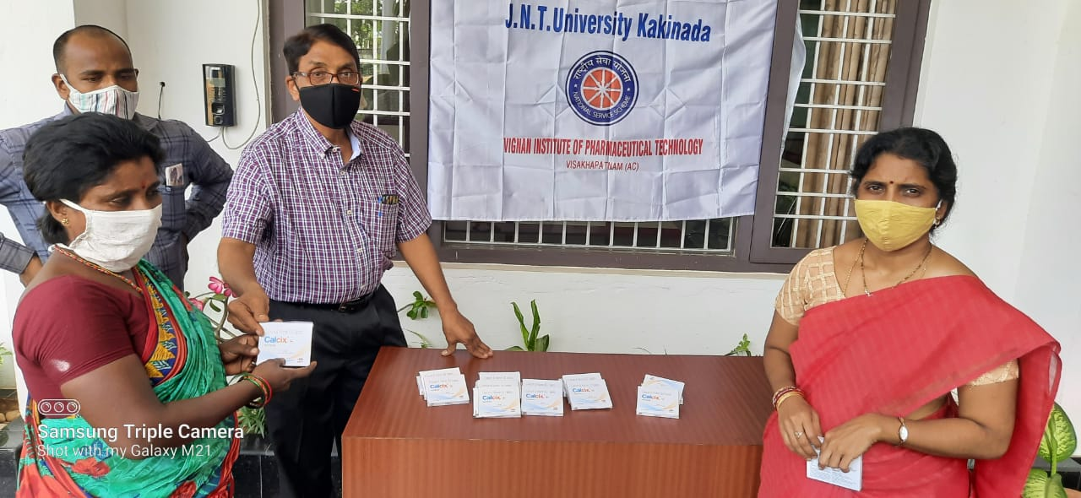

Free medicine distribution to daily workers

