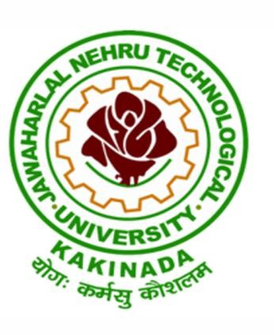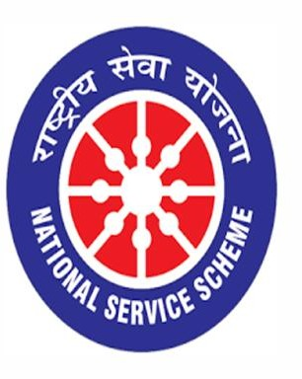

INDEPENDENCE DAY
15/08/2021

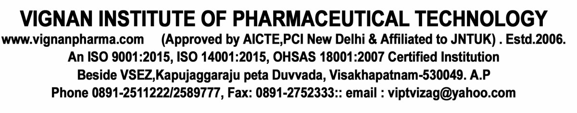

VIGNAN INSTITUTE OF PHARMACEUTICAL TECHNOLOGY
www.vignanpharma.com (Approved by AICTE, PCI New Delhi & Affiliated to JNTUK). Estd.2006.
An ISO 9001:2015, ISO 14001:2015, OHSAS 18001:2007 Certified Institution
Beside VSEZ,Kapujaggaraju peta Duvvada, Visakhapatnam-530049. A.P
Phone 0891-2511222/2589777, Fax: 0891-2752333; email: viptvizag@gmail.com

REPORT Date: 15/08/2021

- NSS UNIT of VIPT has celebrated 75th Independence Day in association with Vignan Institute of Information Technology and Vignan Steel City School on 15/08/2021.
- Staff from two colleges and school was participated in flag hoisting.
- Rector and principal’s admired the sacrifices of freedom fighters.

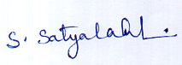
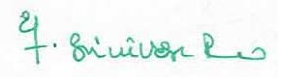
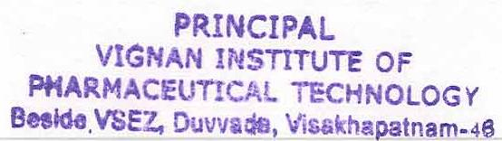
NSS Coordinator Principal

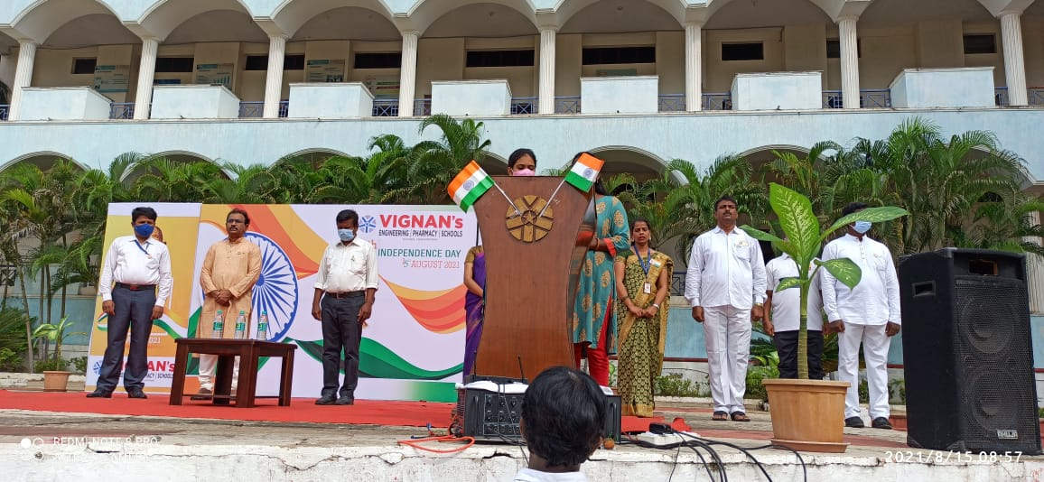

Independence Day Celebration

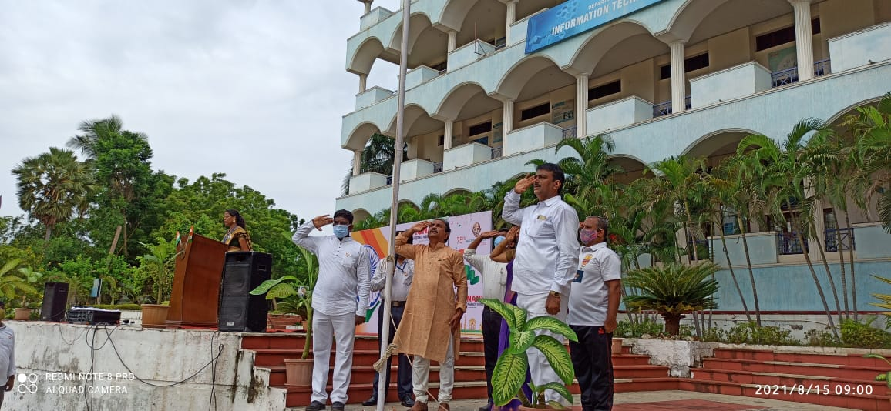

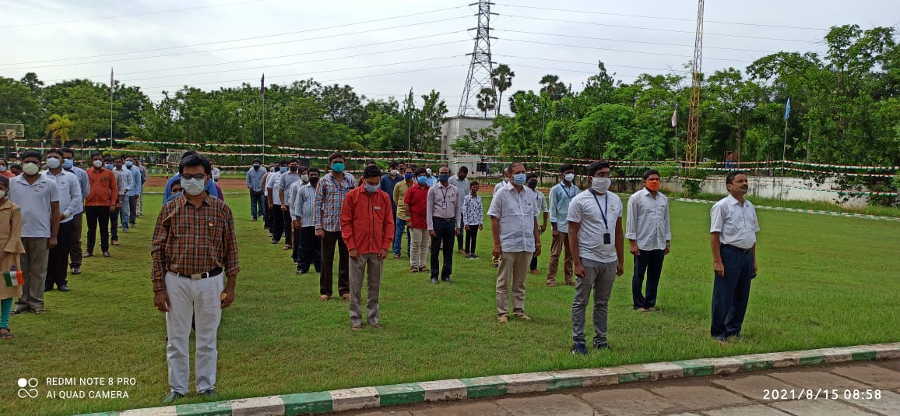

Staff participation

