Student Activity Centre (SAC)
03/08/2019

VIGNAN INSTITUTE OF PHARMACEUTICAL TECHNOLOGY
www.vignanpharma.com (Approved by AICTE, PCI New Delhi & Affiliated to JNTUK). Estd.2006.
An ISO 9001:2015, ISO 14001:2015, OHSAS 18001:2007 Certified Institution
Beside VSEZ ,Kapujaggaraju peta Duvvada, Visakhapatnam-530049. A.P
Phone 0891-2511222/2589777, Fax: 0891-2752333:: email : viptvizag@gmail.com

NOTICE
Date: 30/07/2019

VIPT is conducting the following events for all B.Pharm and Pharm.D students as a part of SAC (Student activity Centre), on Saturday afternoon (03/08/2019). All the students should participate in the below events and enroll your names on or before 01-08-2019.

Quiz Competition on General knowledge, Current affairs, Sports, Movies
Fun games

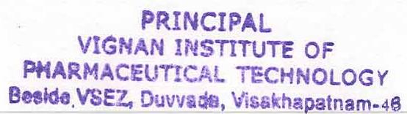
Principal
VIGNAN INSTITUTE OF PHARMACEUTICAL TECHNOLOGY
www.vignanpharma.com (Approved by AICTE, PCI New Delhi & Affiliated to JNTUK). Estd.2006.
An ISO 9001:2015, ISO 14001:2015, OHSAS 18001:2007 Certified Institution
Beside VSEZ,Kapujaggaraju peta Duvvada, Visakhapatnam-530049. A.P
Phone 0891-2511222/2589777, Fax: 0891-2752333:: email : viptvizag@gmail.com

REPORT

Date: 03/08/2019

- 14 teams were participated in quiz event
- Students were participated in fun games and enjoyed.

Principal
Participation of students in quiz

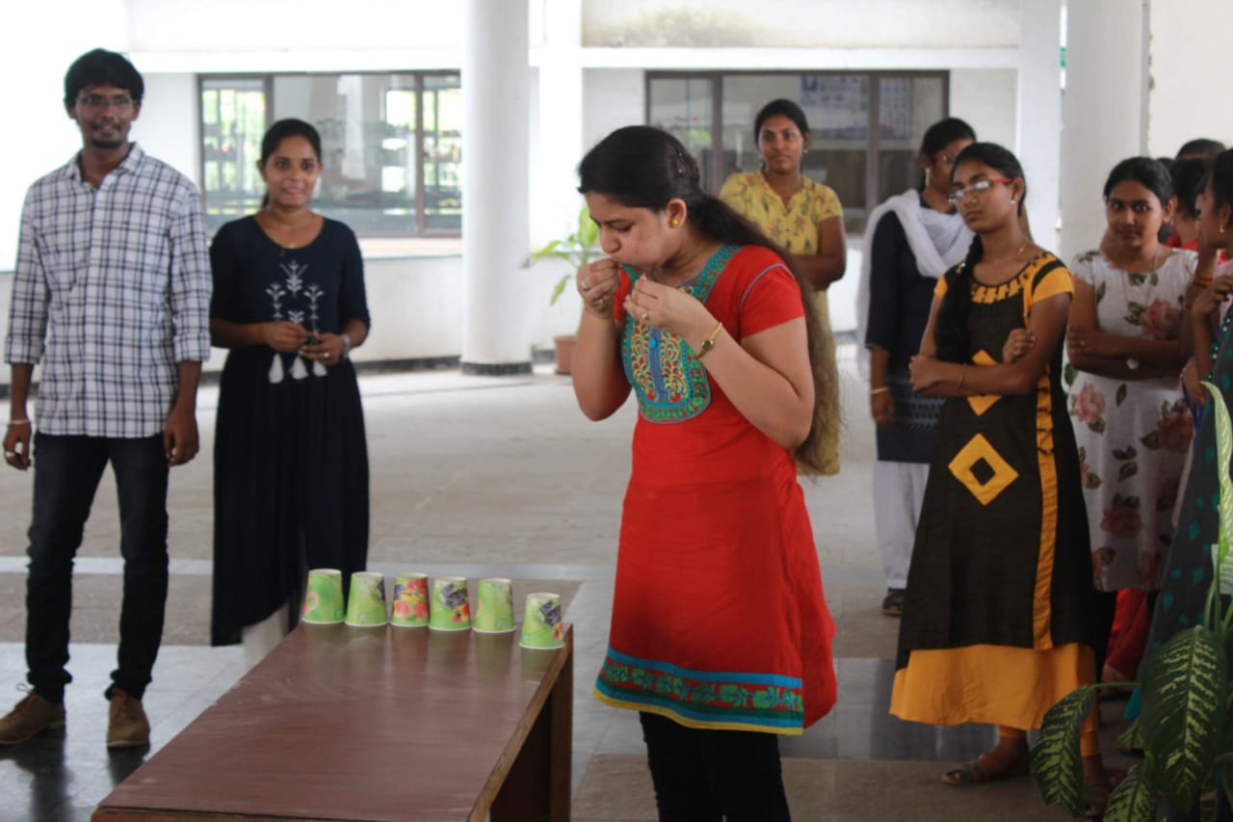
Fun games to students

