Student Activity Centre (SAC)
24/08/2019

VIGNAN INSTITUTE OF PHARMACEUTICAL TECHNOLOGY
www.vignanpharma.com (Approved by AICTE, PCI New Delhi & Affiliated to JNTUK). Estd.2006.
An ISO 9001:2015, ISO 14001:2015, OHSAS 18001:2007 Certified Institution
Beside VSEZ ,Kapujaggaraju peta Duvvada, Visakhapatnam-530049. A.P
Phone 0891-2511222/2589777, Fax: 0891-2752333:: email : viptvizag@gmail.com

NOTICE

Date: 1/08/2019

VIPT is conducting quiz competition for all B.Pharm and Pharm.D students as a part of SAC (Student activity Centre), on Saturday afternoon (24/08/2019). All the students should participate in the below events and enroll your names on or before 22-08-2019.
Topics for quiz:
Current Affairs
General Knowledge
Mythology
History
Pharmacy

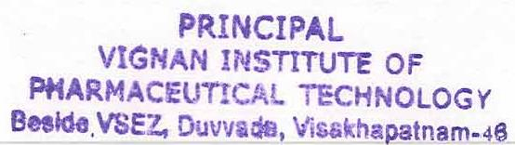
Principal
VIGNAN INSTITUTE OF PHARMACEUTICAL TECHNOLOGY
www.vignanpharma.com (Approved by AICTE, PCI New Delhi & Affiliated to JNTUK). Estd.2006.
An ISO 9001:2015, ISO 14001:2015, OHSAS 18001:2007 Certified Institution
Beside VSEZ,Kapujaggaraju peta Duvvada, Visakhapatnam-530049. A.P
Phone 0891-2511222/2589777, Fax: 0891-2752333:: email : viptvizag@gmail.com

REPORT

Date: 24/08/2019

Total 21 teams were participated in quiz competition
Conducted 5 rounds and one rapid round.
Top scored three teams were selected and distributed prizes.

NSS Coordinator Principal

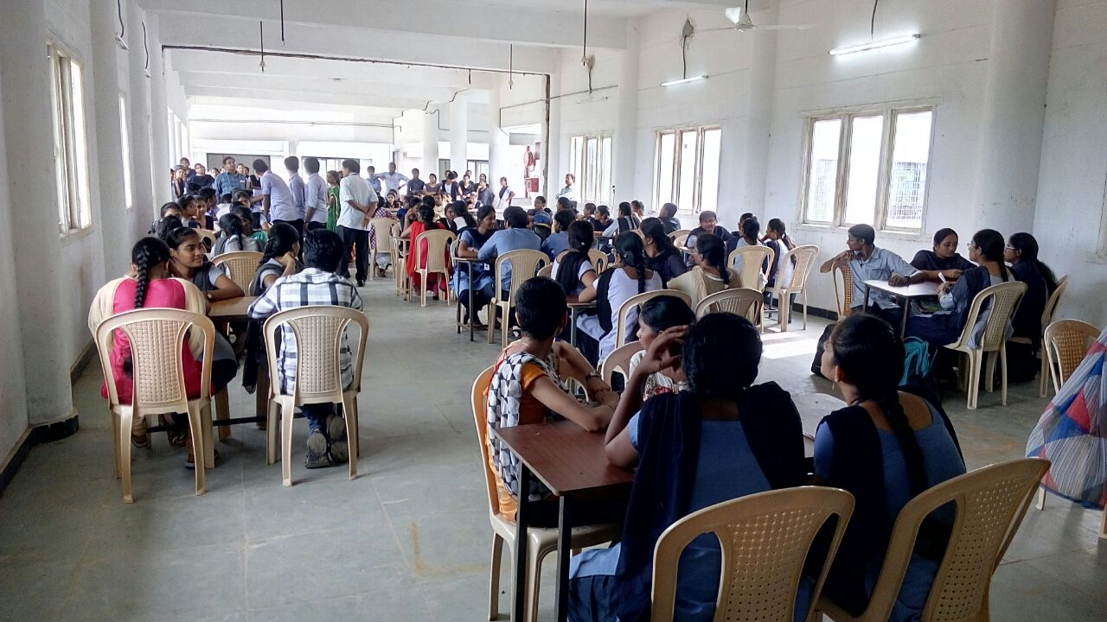Participation of students in quiz competition
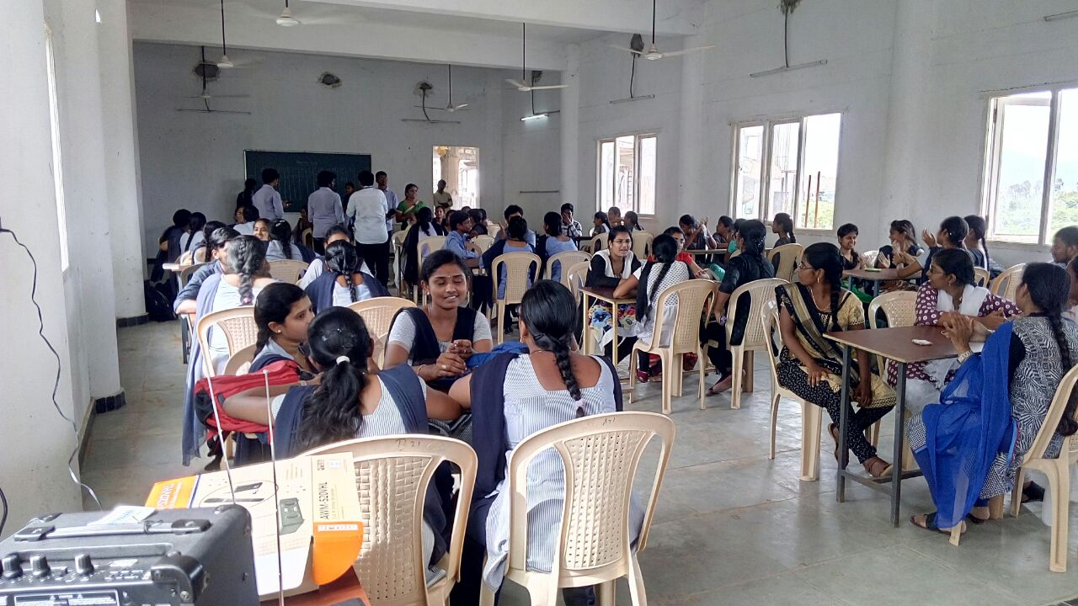

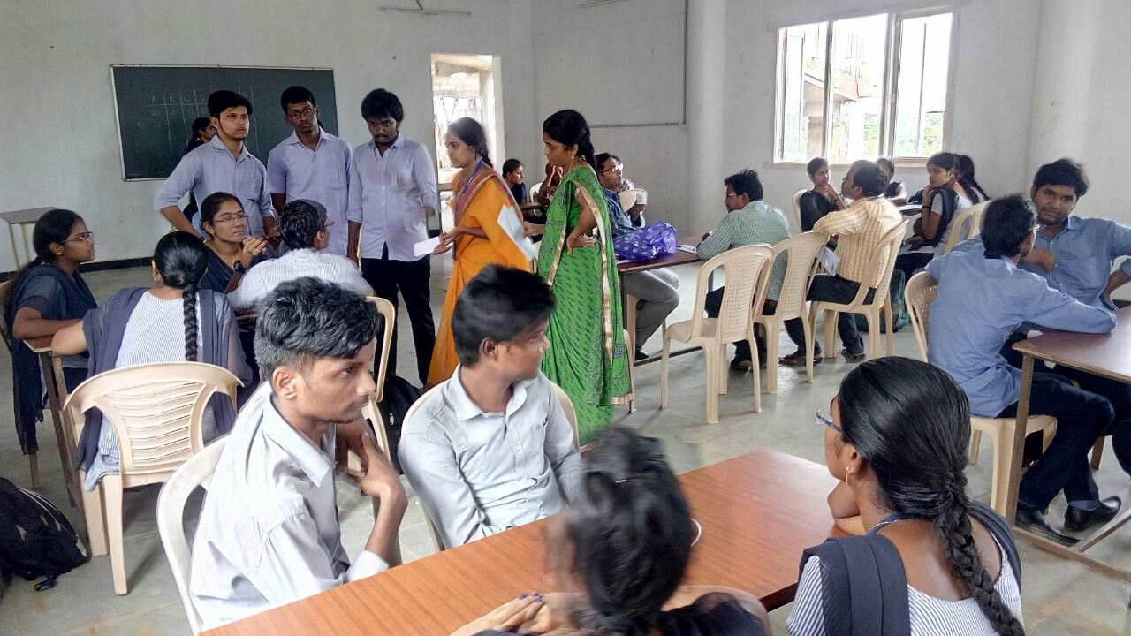

Participation of students in quiz competition

